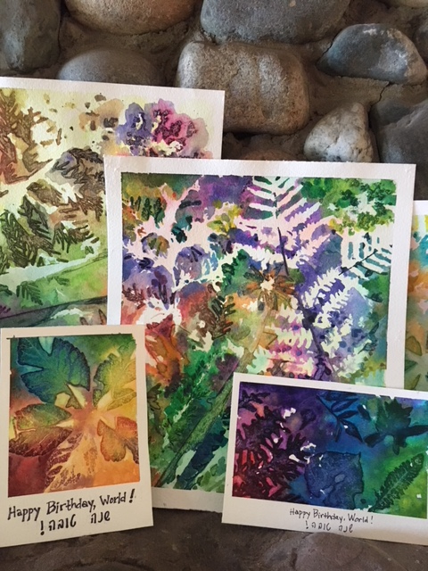

“Happy Birthday, World!!!” Rosh HaShanah Cards

Rosh Hashanah is also referred to as the “Birthday of the World”. What could reflect the holiday better than sending a Rosh Hashanah card with beautiful images of nature? In creating these cards you not only send a colorful image of our natural world but you experience it through the making. Here is how…

Materials needed:

- Green leaves that are supple (not dried) with a rather flat surface. Look for leaves with interesting shapes! Keep loosely in a closed plastic bag with a moistened paper towel folded inside.
- Watercolor paper. You need a good quality paper to hold a lot of the watery paint. I used Strathmore, size 11x15 and cut it into four 5x7 sheets for a single sheet card. Another option is to make two folding cards from a page measuring 10x7. You may have another size or style you like!
- Optional: Size A7 envelopes to fit your 5x7 cards. (You can order these online.) However, you can create a card to fit any envelopes you have on hand.
- Watercolor brush- a soft bristled brush that holds water well
- Watercolors- I would avoid any “washable” paints as they may not have sufficient pigment. I used Prang. For best results, get quality watercolors like this or better.
- Cup for water
- Masking or painters tape
- Flat cardboard or cookie sheets to tape paper onto
- Optional: scissors, ruler and pencil to cut paper
- Little stones or gravel or something to weigh down any “jumpy” leaves after painting them

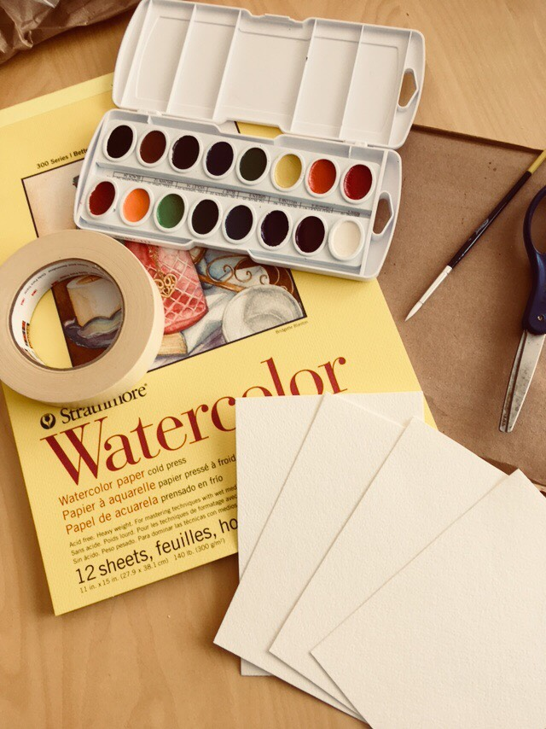

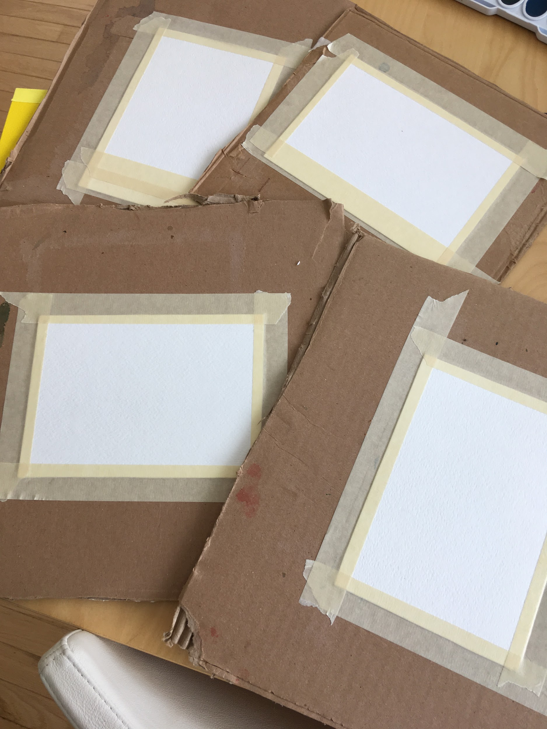

Tape your paper edges to your background to make both an edge and to hold in place until dry. If you want to allow for a blank area to have room for writing a greeting, add tape to that area.

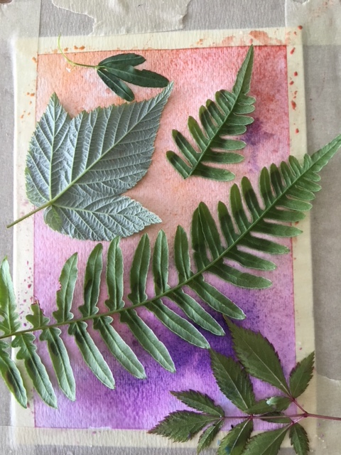

Brush on a simple light colored wash over the paper. Arrange leaves smooth side down (underside facing you).

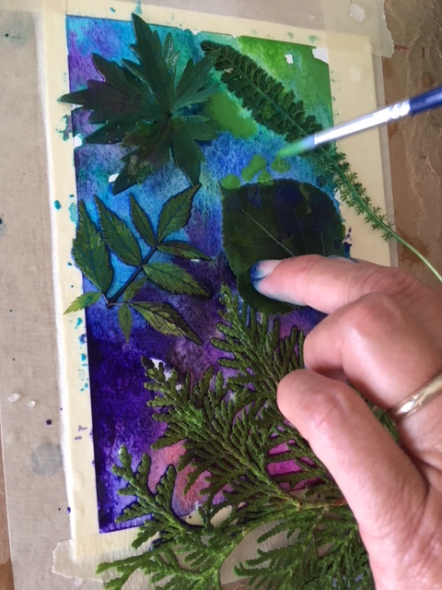
Holding the leaves in place, gently dab the watery paint on and around the leaves. Try not to disturb the leaves as you paint. (For younger children, one large leaf, like a maple, would be easier to work with rather than using multiple leaves.)
Saturate the paper with beautiful color!

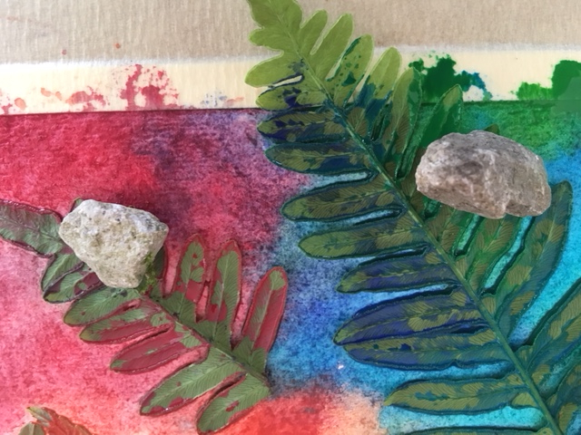
Place small rocks or gravel (optional) on areas that tend to come off the page. For very flat leaves, it will not be necessary.

Leave to dry in a safe place (far from curious fingers) overnight.

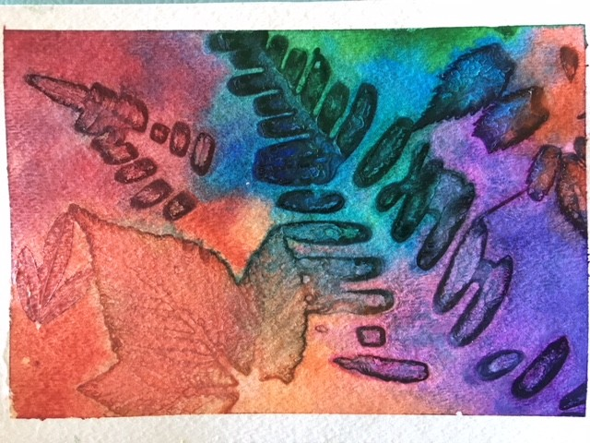

When background paint is dry, gently remove stones and leaves and carefully pull back your tape.
Voila! Isn’t that exciting?!
Now make more!

You can take your favorite piece(s) to a commercial printer and make multiples or make as many originals as you enjoy making.

Shanah Tovah!!

